
ST ANDREW’S JUNIOR COLLEGE
Preliminary Examinations
Higher 2

H2 GEOGRAPHY 9173/02
Paper 2 12 September 2024
INSERT 3 hours

READ THESE INSTRUCTIONS FIRST

This insert contains all the Resources referred to in the questions.

This document consists of 6 printed pages.

[Turn over
Resource 1 for Question 1

Map of Kallang River in Bishan Ang Mo Kio Park, Singapore

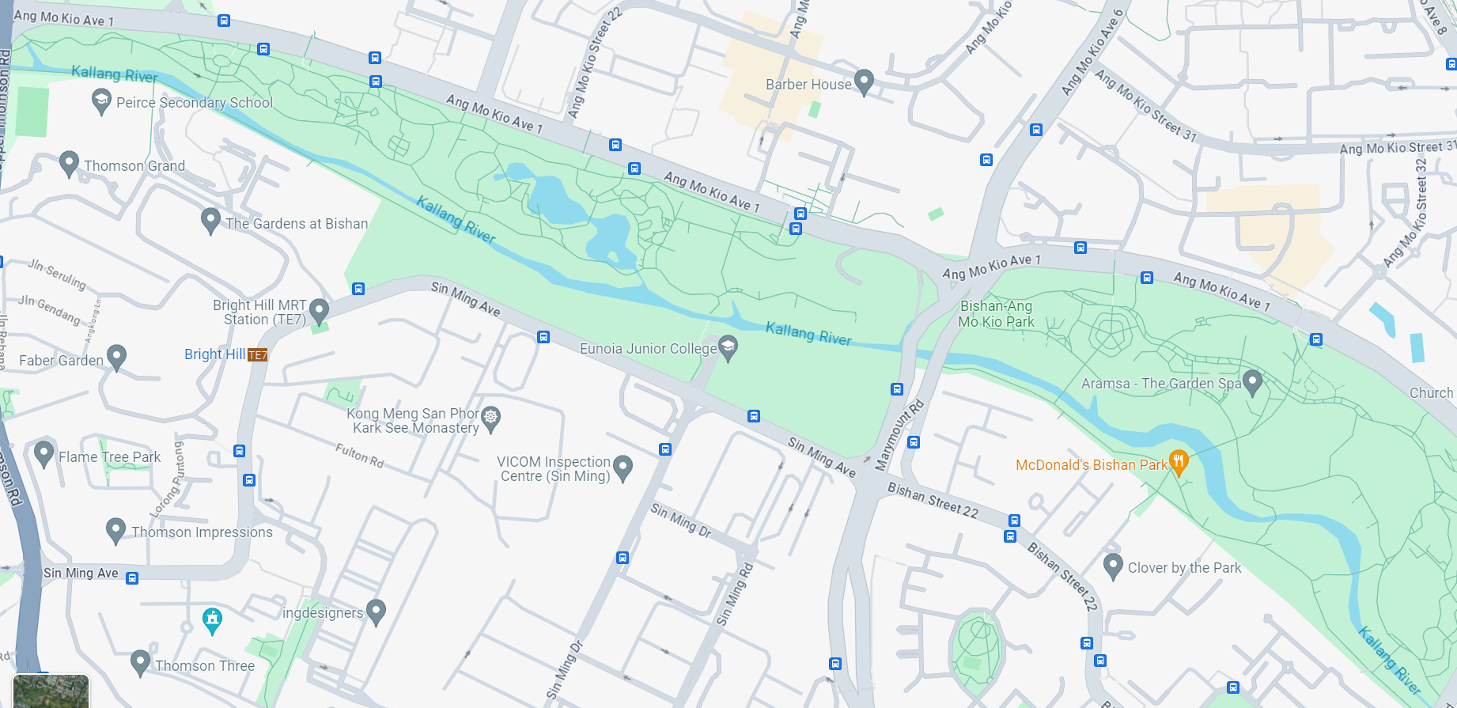
Site A

Site B

Direction of river flow

The course of the Kallang River flowing through Bishan-Ang Mo Kio Park from Site A to Site B is about 2.7 km.

: Direction of river flow

Resource 2 for Question 1

Photographs of sites A and B

Site A

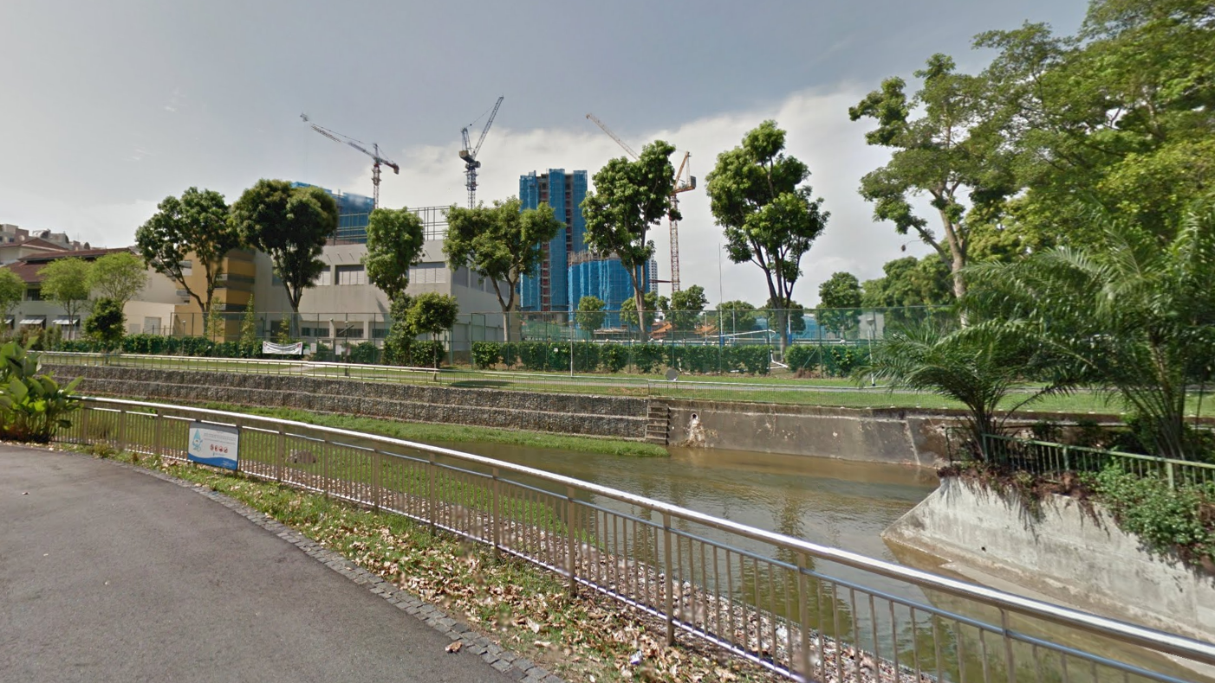

: Direction of river flow

Site B

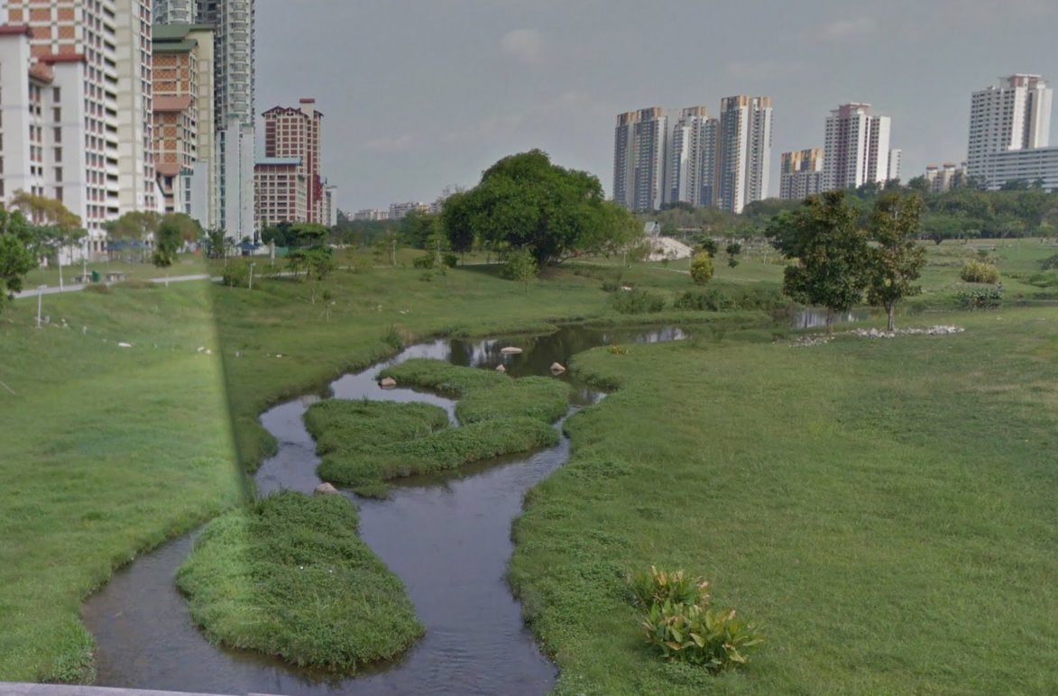

: Direction of river flow
[Turn over

Resource 3 for Question 1

Data collected to calculate the velocity at Sites A and B

Site A  Time taken for ping-pong ball to travel 5 m (in seconds) |  |  |  |  | Site B  Time taken for ping-pong ball to travel 5 m (in seconds)
 | 1st Reading | 2nd Reading | Average | Velocity | 1st Reading | 2nd Reading | Average | Velocity
11am | 53 | 55 | 54 | 0.093 | 70 | 74 | 72 | 0.069
1pm | 54 | 55 | 54.5 | 0.092 | 60 | 66 | 63 | 0.079
2pm | 54 | 56 | 55 | 0.091 | 71 | 72 | 71.5 | 0.070
 |  |  | Average Velocity | 0.092 |  |  | Average Velocity | 0.073
[Turn over

Resource 4 for Question 2

Number of persons added to selected urban areas per hour

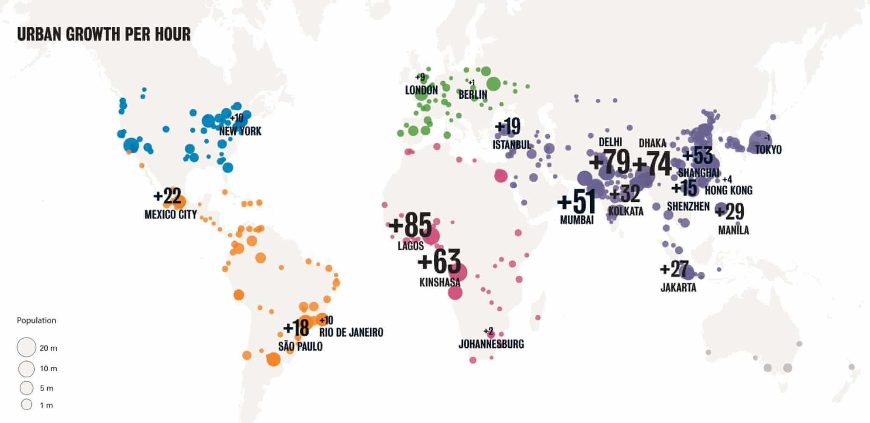
Resource 5 for Question 2

Photos of Tianzifang before and after urban reimaging

Before | After
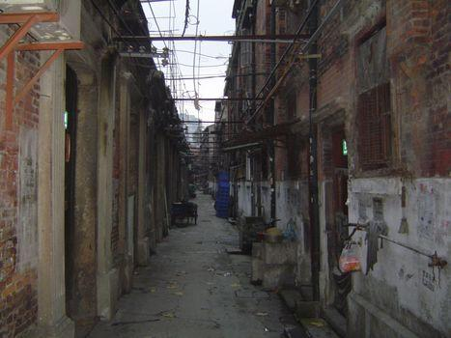 | 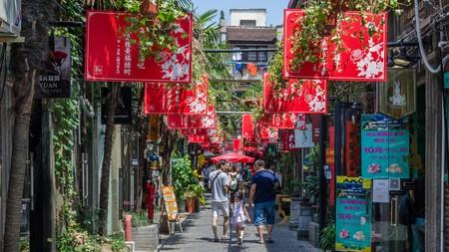

[Turn over

Resource 6 for Question 2

Shanghai’s ranking in two different urban liveability indicators in 2016

Liveability Indicator | Criteria used | Ranking of Shanghai (2016)
Mercer Quality of Living Survey  The scores attributed to each factor, which are weighted to reflect their importance to expatriates, permit objective city-to-city comparisons. The result is a Quality of Living index that compares relative differences between any two locations evaluated. For the indices to be used effectively, Mercer has created a grid that enables users to link the resulting index to a quality of living allowance amount by recommending a percentage value in relation to the index. | - Political and social environment  - Economic environment  - Socio-cultural environment  - Medical and health considerations  - Schools and education  - Public services and transportation  - Recreation  - Consumer goods  - Housing  - Natural environment | 103/231 cities worldwide
Global Liveability Index  Each factor in a city is rated as acceptable, tolerable, uncomfortable, undesirable or intolerable. For qualitative indicators, a rating is awarded based on the judgment of in-house analysts and in-city contributors. For quantitative indicators, a rating is calculated based on the relative performance of a number of external data points. | - Stability  - Healthcare  - Culture and environment  - Education and Infrastructure | 82/140 cities worldwide

